Classification Assignment

Problem Statement or Requirement:

A requirement from the Hospital, Management asked us to create a predictive
model which will predict the Chronic Kidney Disease (CKD) based on the
several parameters. The Client has provided the dataset of the same.

1.) Identify your problem statement
- Machine Learning-Because the computer is learning patterns from data and giving predictions automatically.
- Example:We give:
- age
- bp
- sugar
- hemoglobin
- And the model learns:“Patients with these values usually have CKD.”
- Then for a new patient, it predicts:CKD or No CKD
- So the computer is learning from past data → therefore it is Machine Learning.

2.) Tell basic info about the dataset (Total number of rows, columns)
- 400 rows
- 25 columns

3.) Mention the pre-processing method if you’re doing any (like converting string to number – nominal data)
Pre-processing Techniques Used
- Handling missing values
- Converting categorical/string data into numerical data
- Feature selection
- Splitting dataset into training and testing data

4.)Finding the best model:

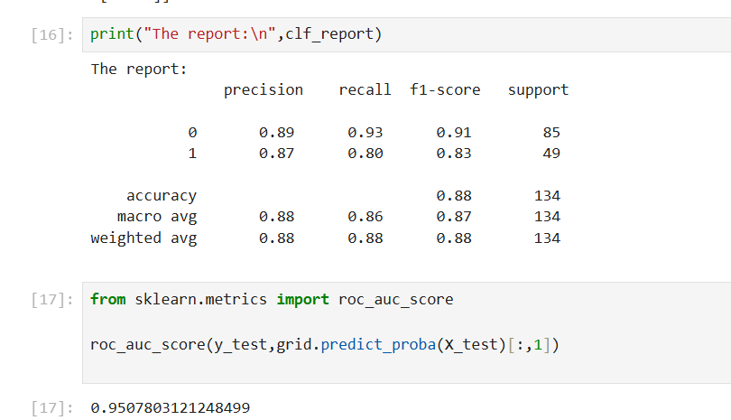

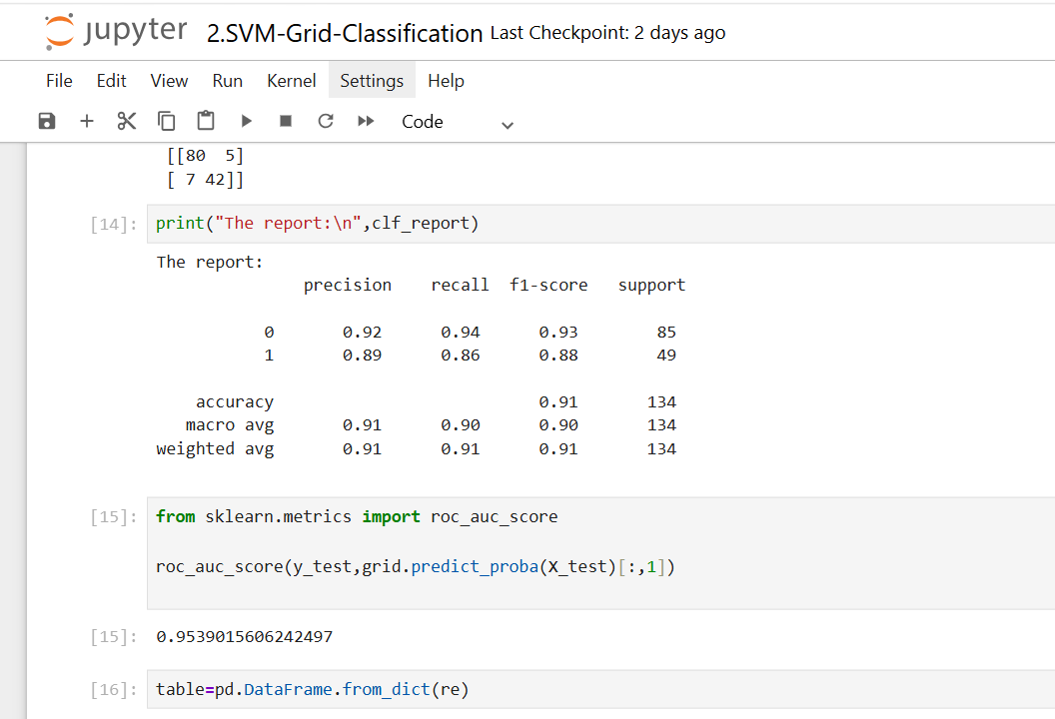

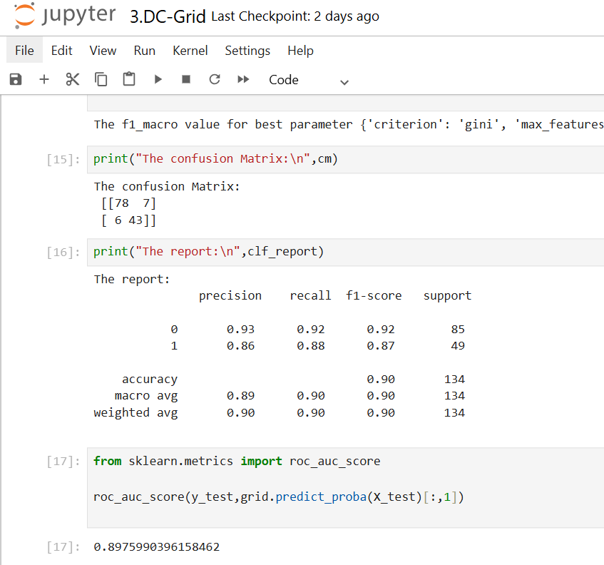
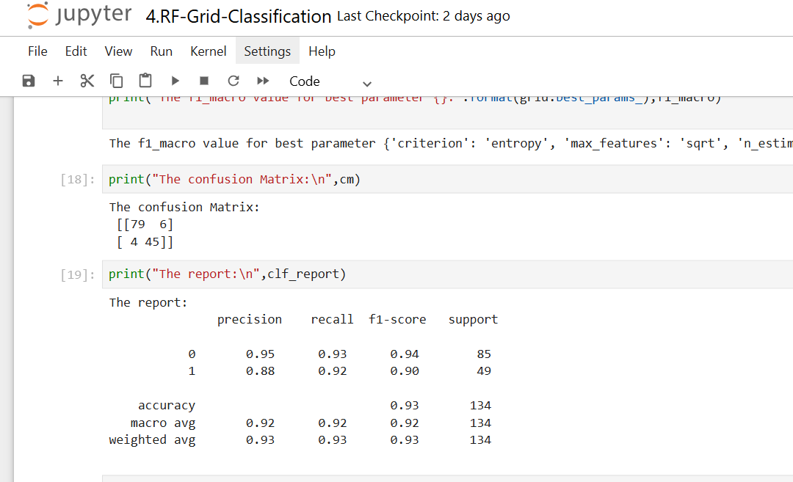

The good model for this dataset is SVM since it has Recall value $0.94% and roc score is $95%

